**Robotic Process Automation**

**Certified Journal**

**Submitted in partial fulfilment of the**

**Requirements for the award of the Degree of**

**MASTER OF SCIENCE**

**(INFORMATION_TECHNOLOGY)**

**By**

**Anushka Sanjay Bhopi**



**DEPARTMENT OF INFORMATION TECHNOLOGY**

|  |  |
| --- | --- |
| |  | | --- | | **KERALEEYA SAMAJAM (REGD.) DOMBIVLI’S**  **MODEL COLLEGE (AUTONOMOUS)**  **Re-Accredited ‘A’ Grade by NAAC**  *(Affiliated to University of Mumbai)* | |

FOR THE YEAR

**(2023-24)**

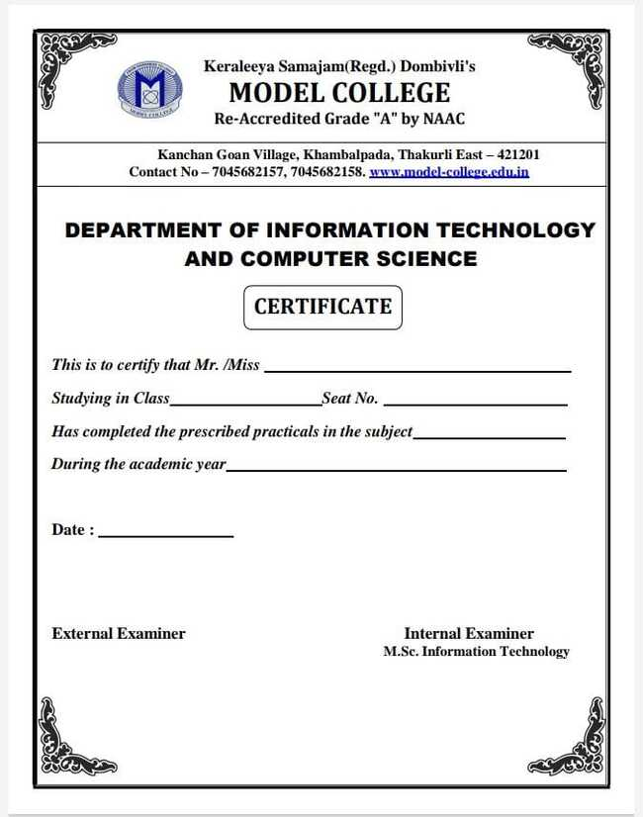

|  |  |  |  |
| --- | --- | --- | --- |
| **Sr.No** | **Title** | **Date** | **Signature** |
| 1A | Create a simple sequence-based project. (Take input from the user store it in a variable and print output) | 21-10-2023 |  |
| 1B | Create a flowchart-based project. (Get two numbers from the user and check if it is  equal or not. If not equal, enter two numbers again). | 21-10-2023 |  |
| 1C | Create an UIpath robot that can empty a folder in gmail solely based on the recording | 04-11-2023 |  |
| 2A | Automate UiPath Number Calculation (Subtraction,Multiplication, Division of numbers). | 02-12-2023 |  |
| 2B | Create an automation UiPath project using different types of variables. (number, DateTime, Boolean, generic, array, data table) | 02-12-2023 |  |
| 3A | Create an automation UiPath Project using decision statements. (take the number from the user, the check is it even or odd). | 09-12-2023 |  |
| 3B | Create an automation UiPath Project using looping statements | 09-12-2023 |  |
| 4A | Automate any process using the basic recording. (Change the font, font style, and font size of written data inside the notepad). | 09-12-2023 |  |
| 4B | Automate any process using web recording. (Jubin 8085 simulator) | 06-12-2023 |  |
| 5 | Consider an array of names. We have to find out how many of them start with the letter "a". Create an automation where the number of names starting with "a" is counted and the result is displayed. | 06-12-2023 |  |
| 6 | Create an application automating the read, write and append operation on an excel file. | 13-01-2024 |  |
| 7 | Demonstrate the following activities in UiPath:  1. Mouse (click, double click, and hover)  2. Type into  3. Type Secure text | 20-01-2024 |  |
| 8 | Demonstrate the following events in UiPath:  1. Element triggering event  2. Image-triggering event  3. System Triggering Event | 20-01-2024 |  |
| 9 | Automate a process for sending mail | 20-01-2024 |  |

**PRACTICAL 1A**

**Create A Simple Sequence-Based Project. (Take Input From The User Store It In A Variable And Print Output)**

**Process Steps :**

1. Search for Sequence activity in the activity panel drag and drop the sequence activity inside the designer

panel.

2. Click on sequence, and add Input Dialog activity inside the sequence. Give appropriate Dialog Title,

Input Label, Input Type, Value enters values. Dialog Title as “User input” and Input Label as “Enter your

name:” must be in double quotes.

3. Create a variable in the Variable panel with name as Name, Variable Type as String, and Scope as Main

Sequence.

4. Add activity Message Box, enter the variable name with text as “My name is”+ Name.

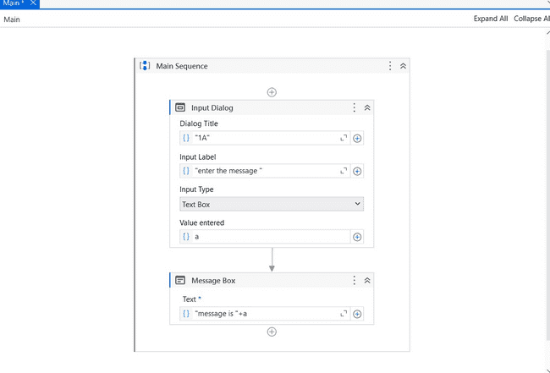

5. Run the process using the **Run** Button.

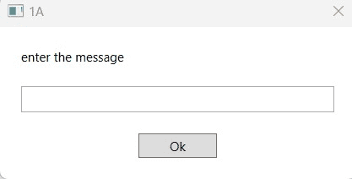

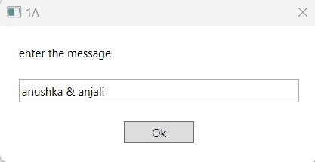

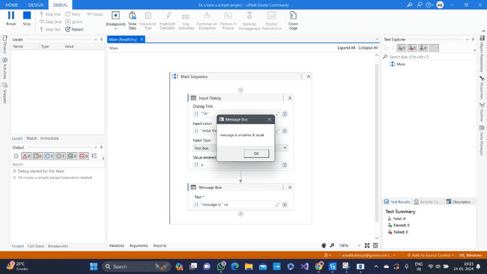

**PRACTICAL 1B**

**Create A Flowchart-Based Project. (Get Two Numbers From The User And Check If It Is Equal Or Not. If Not Equal, Enter Two Numbers Again).**

**Process steps :**

1. Search for Flowchart activity in the activity panel and add that activity inside the designer panel.

2. Click on the flowchart activity and add two Input Dialog activities inside the flowchart. Give appropriate

Dialog Title, Input Label, Input Type, and Value entered. Dialog Title as “user input” and Input label as

“Enter Num1”,” Enter Num2” must be in double quotes.

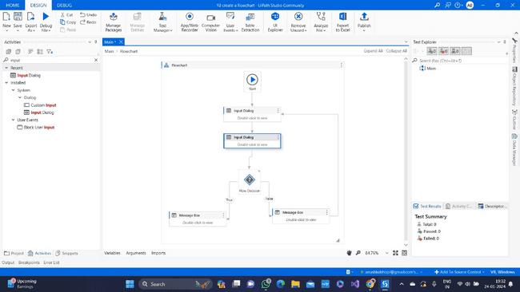

3. Create variables inside the Variable panel with names Num1 and Num2, variable type as Int32, and variable scope as a flowchart. Assign variable name in the value entered to each Input Dialog.

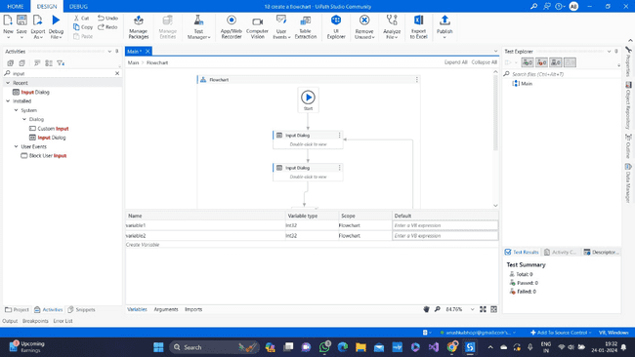

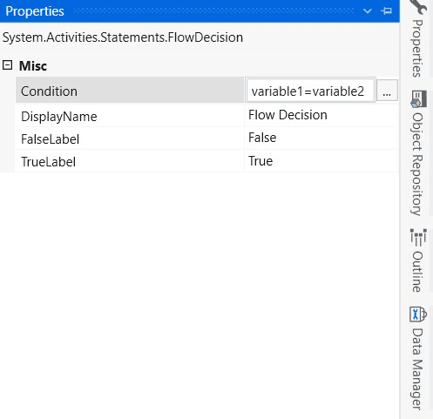

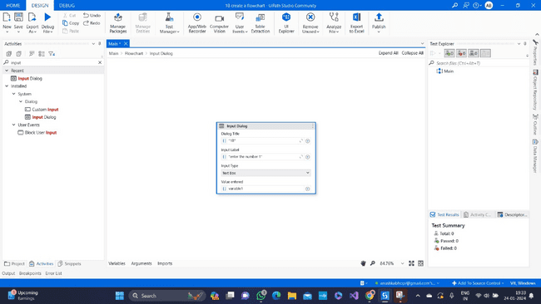

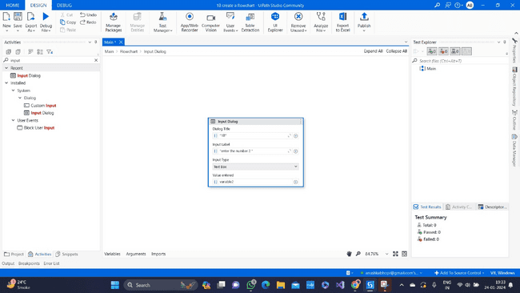

4. Add Flow Decision activity in flow. inside the properties panel Give the condition “Num1 = Num2”. If

the condition is true then flow goes to the true block and if the condition is false then flow goes to the

false block.

5. Add Message Box activity and enter the text as “Num1 and Num2 are equal” in the true block. And

“Num1 and Num2 are not equal “in the false block.

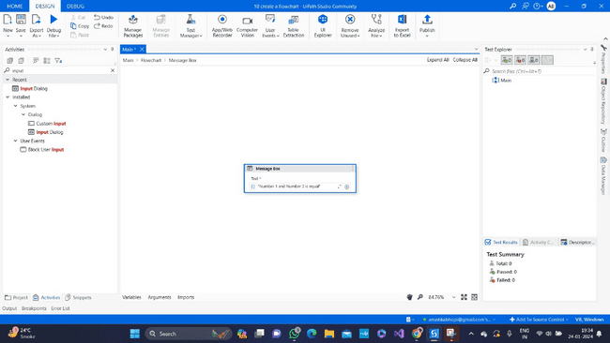

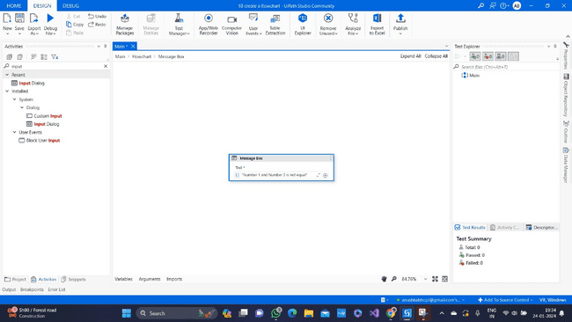

6. If the condition is not equal direct the flow to the input dialog activity. Run the process using Run Button.

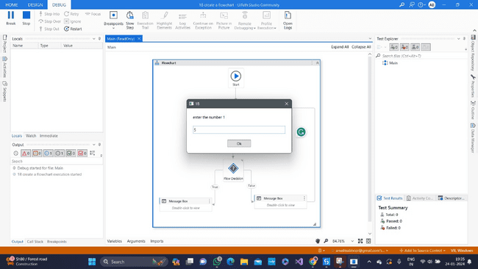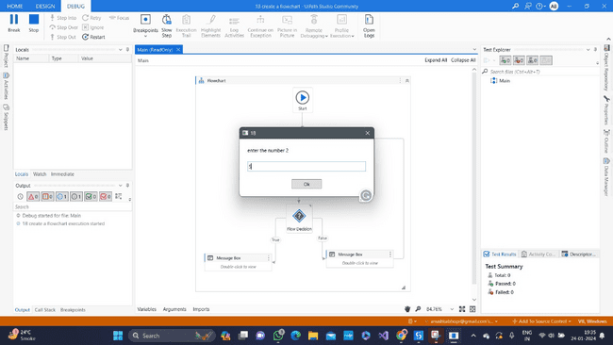

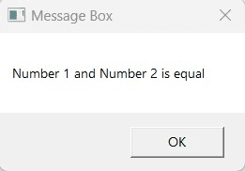

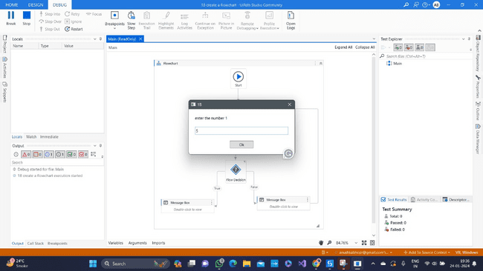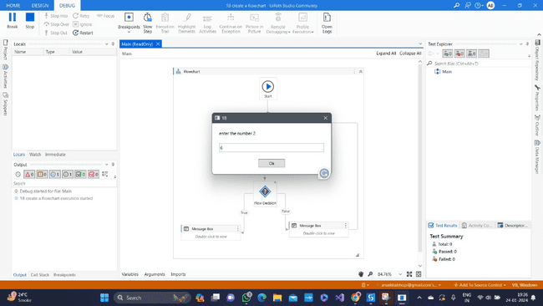

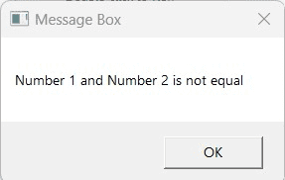

**PRACTICAL 1C**

**Create An Uipath Robot That Can Empty A Folder In Gmail Solely Based On The Recording**

**Process Steps :**

1. Add Sequence activity inside the designer panel.

2. Start recording using the Web/Application recorder on Ribbon.

3. Click on the Gmail login page on the browser. Click the Input field, select the Type Into option and

click on the confirmation Button. Enter your email address in Type Into.

4. Click on the Next button and click on the confirmation button. It will go to the next process.

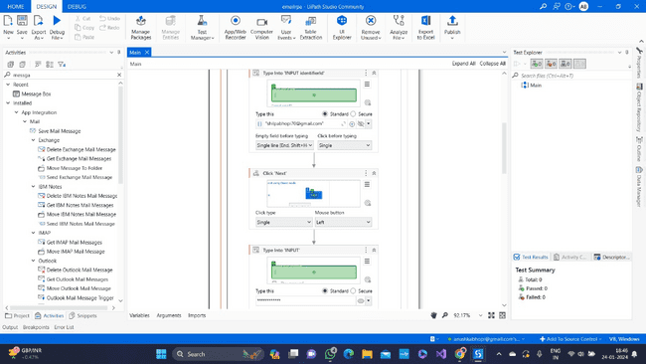

5. Click the Input field of the Password, select Type Into and click on the confirmation button. Enter your

password in Type Into and select the invisible option, it will show an asterisk instead of password ******* characters.

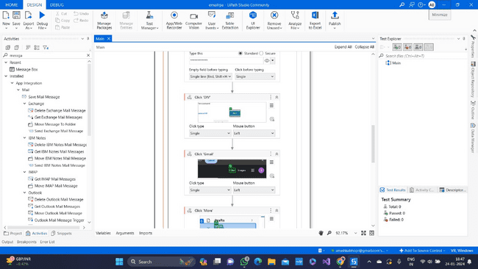

6. Click on the Next button and click on the confirmation button now you will log in to a Gmail account.

7. Here we can empty the trash bin. Click on the More option and confirmation button.

8. Select the Bin option from click it and confirm it.

9. Select mail to delete from a bin and click on confirm button.

10. Click on the Delete Forever button and click the confirmation. You will delete one or more mail from

the bin permanently.

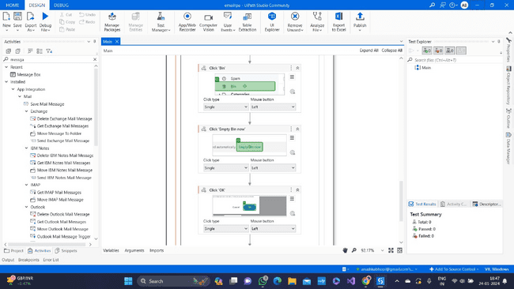

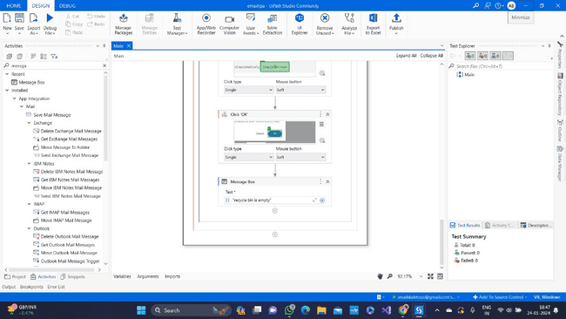

11. Click the Run Button to run the process.

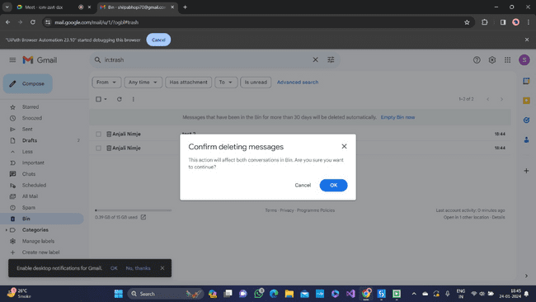

**PRACTICAL 2A**

**Automate Uipath Number Calculation (Subtraction,Multiplication, Division Of Numbers).**

**Process steps :**

1. Add Sequence activity inside the designer panel.

2. Add two Input Dialog activities inside the sequence. Give the appropriate Input Tittle, Input Label, Input

Type, and Value entered. Dialog Title as “Calculator” and Input Label as “Enter Num1:”, and “Enter

Num2:” within double-quotes.

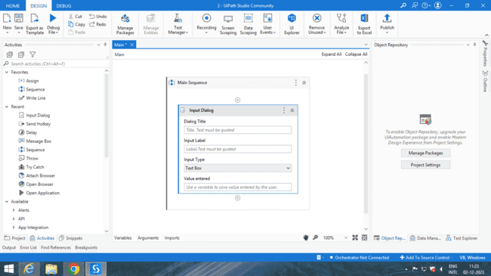

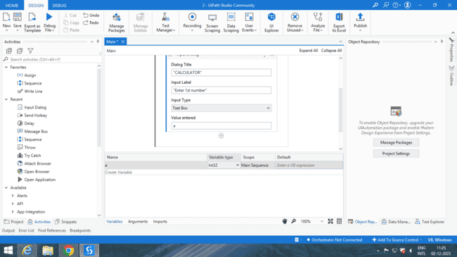

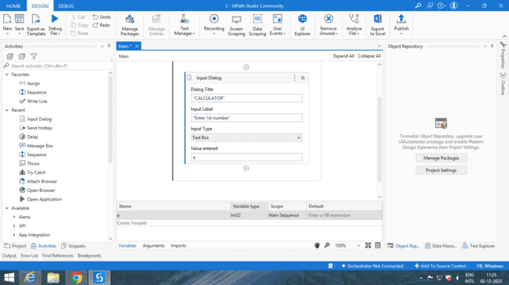

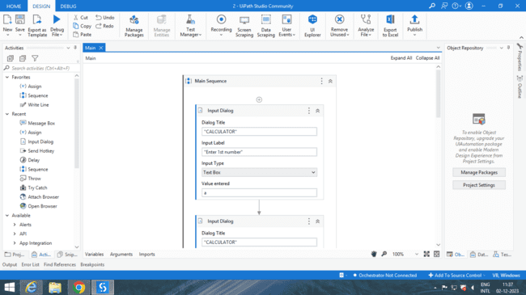

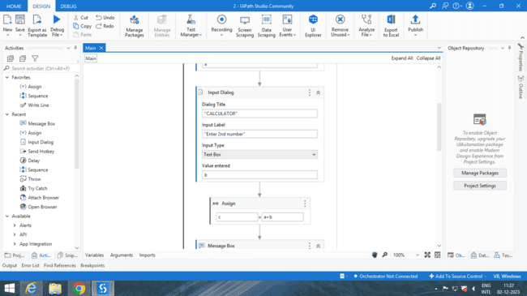

4. Add Assign activity, assign addition, subtraction, multiplication, and division operation to the result

variable as “result = Num1+Num2”, ”result=Num1-Num2”, ”result=Num1*Num2”,

”result=Num1/Num2”.

5. Add Message Box activity after each Assign activity to print the result of operations. Add the result

variable side the text of the message box activity

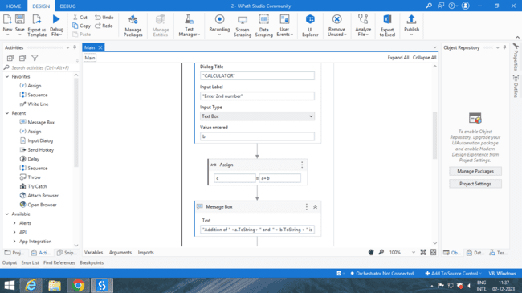

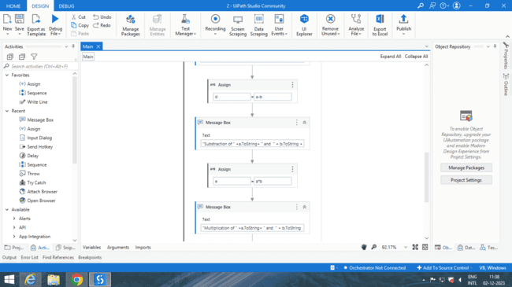

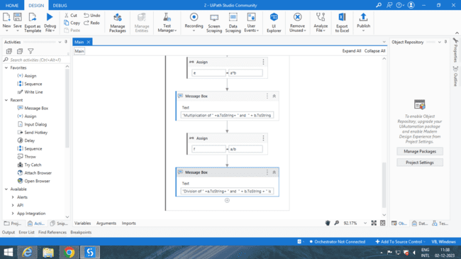

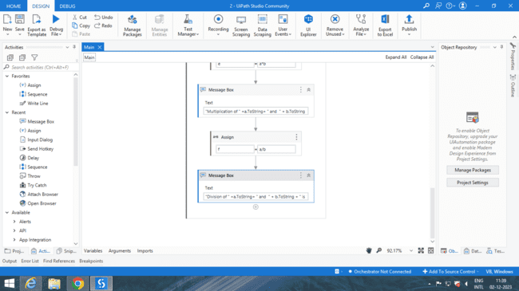

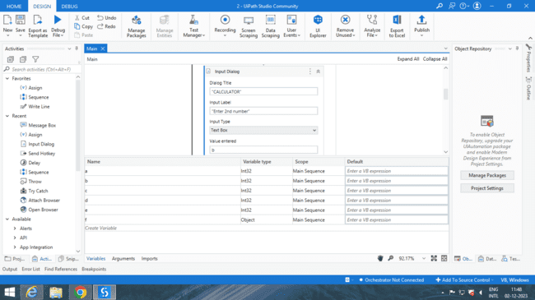

6. Run the process using Run Button

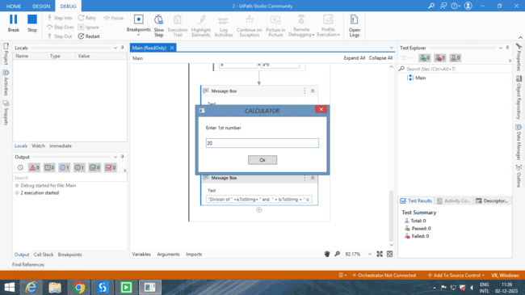 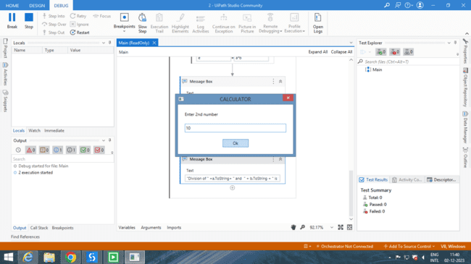

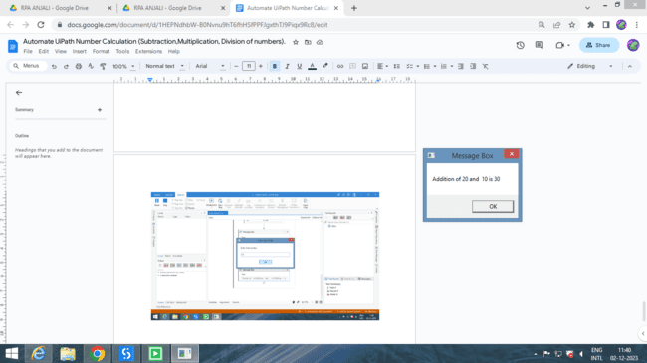 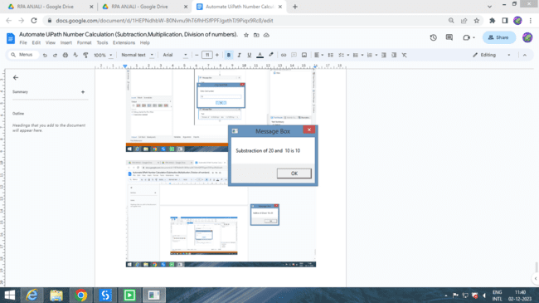

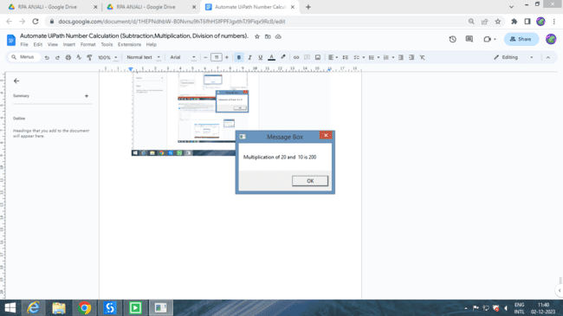 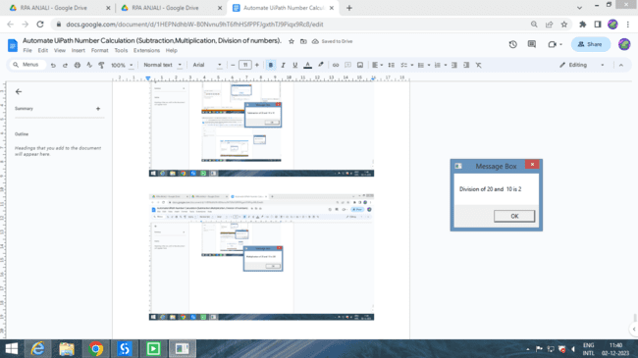

**PRACTICAL 2B**

**Create An Automation Uipath Project Using Different Types Of Variables. (Number, Datetime, Boolean, Generic, Array, Data Table)**

1. **BOOLEAN**

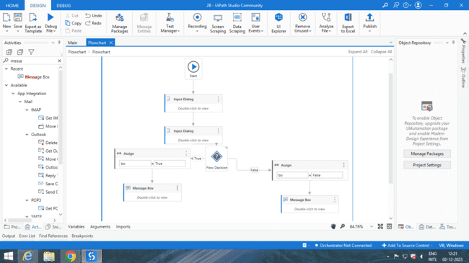

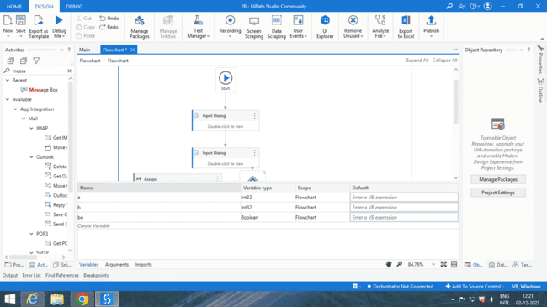

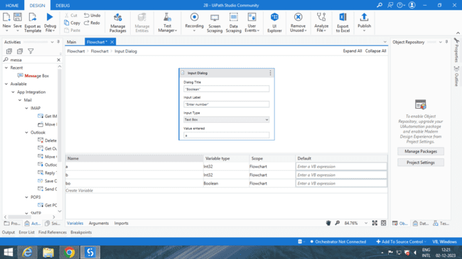

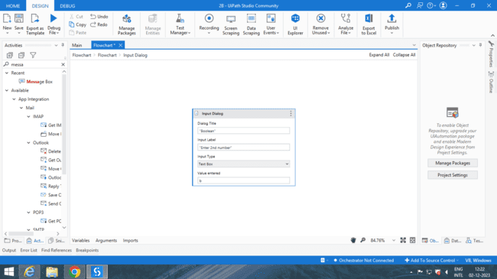

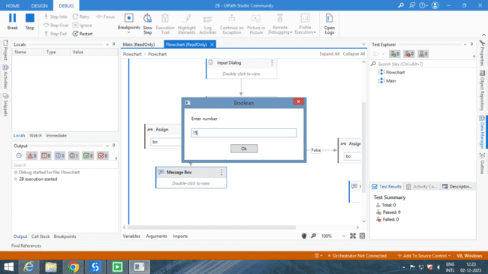 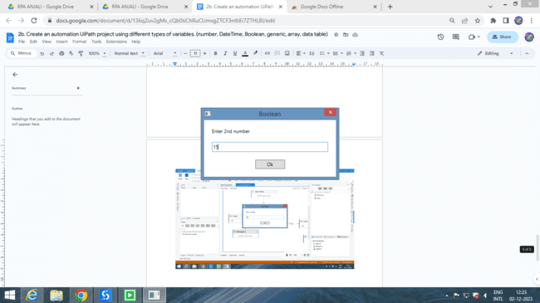

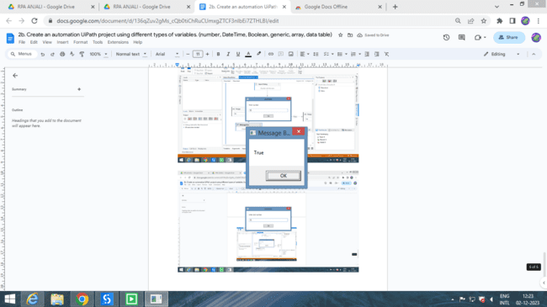

 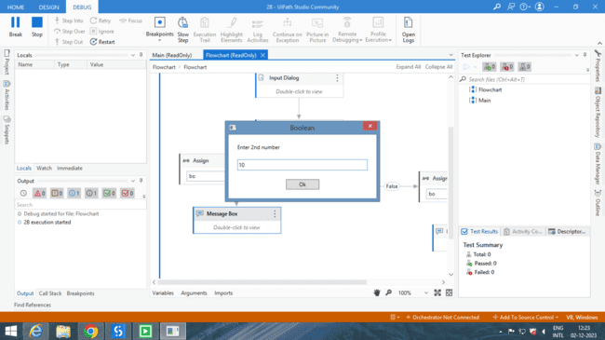

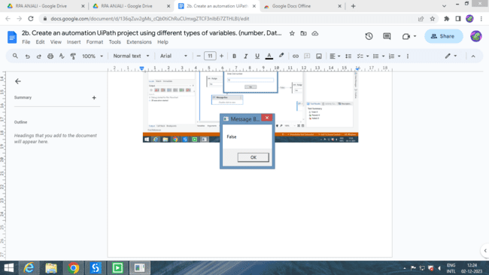

**2.GENERIC**

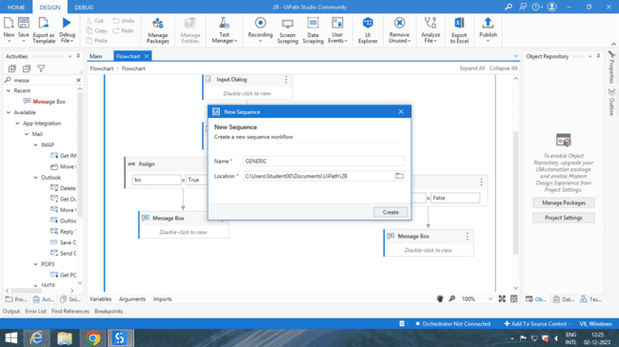

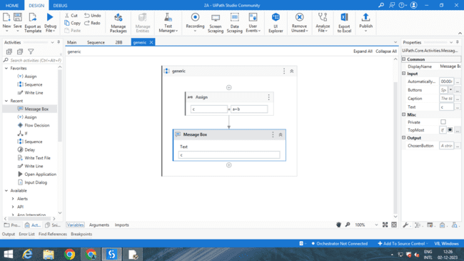

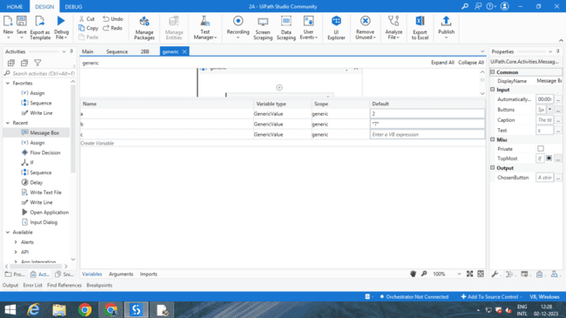

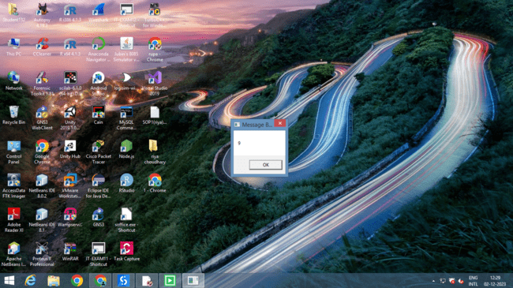

**3.ARRAY**

Array variable

**Process step:**

1. Search for Sequence Activity, drag and drop Sequence activity added in the designer panel.

2. Inside the variable panel create a variable currentItem with Variable Type String Type,

Scope as the sequence.

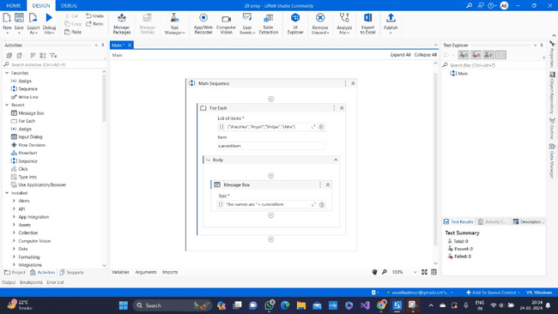

3. Add For each activity inside the sequence. Enter the variable that you want to print in the body to ForEach

part assign variable currentItem inside the in part. 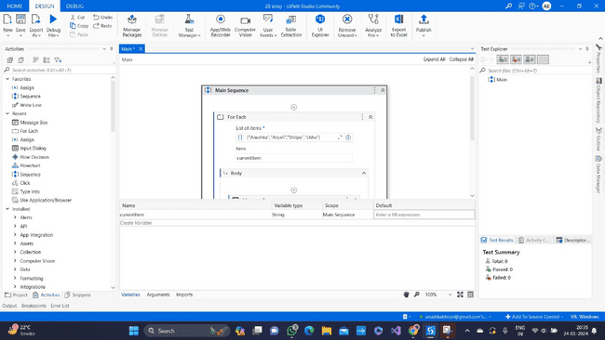

4. Add a Message Box activity in the body of Each activity. Enter text as “the names are” + currentItem

5. Use Run Button to run the process. it will print all elements inside the array.

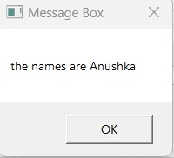 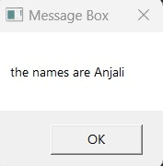

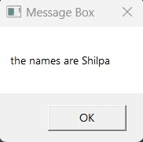 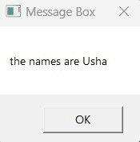

**4.NUMBERS**

**Process Steps:**

1. Create age and name variables inside the variable panel. Age variable with Type Int32, Scope as

sequence, and the name variable with Type String, scope as Sequence.

2. Add Sequence activity inside the designer panel.

3. Add two Input Dialog activities inside the Sequence for the person name and age respectively. Give

Input Title as “person details”. Input Lable as “ Enter your name: “ and “Enter your age: “ always in

double-quotes. Select Input Type as “TextBox” and value entered enter the variables name created in

the variable panel as name and age respectively.

4. Add Message Box activity after that and add Text as “ Your name is “+name+ “ and age is

”+age.ToString+” .“.

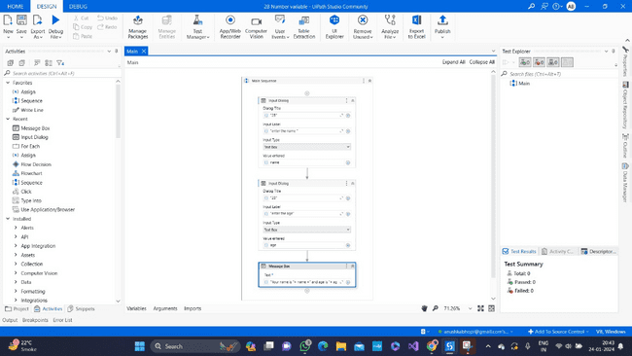

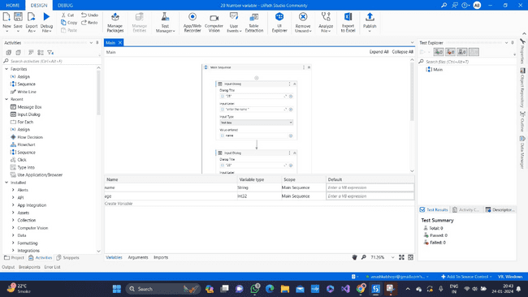

5. Run the process using Run Button.

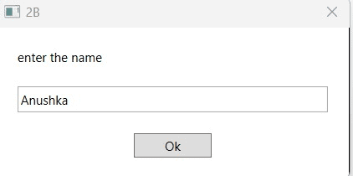 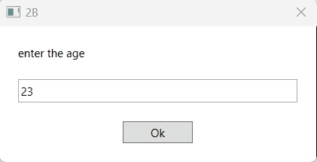

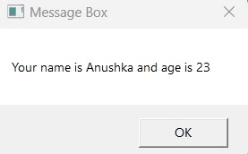

**5.DATATABLE**

1. Create variables inside the variable panel with the name TableData and result. With Variable type for

TableData “DataTable” and “String” respectively. Variable scope is Sequence for both the variables.

2. Add Sequence activity in the designer panel.

3. Add Data Table activity inside Sequence add Colum in it as names and age add some data in it.

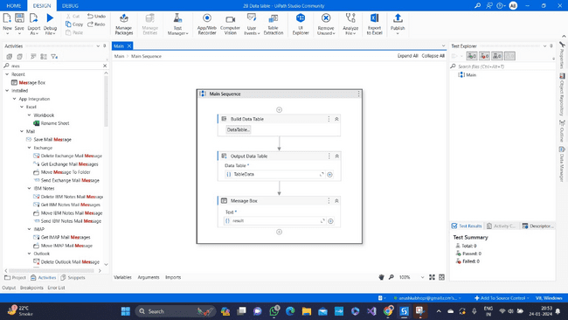

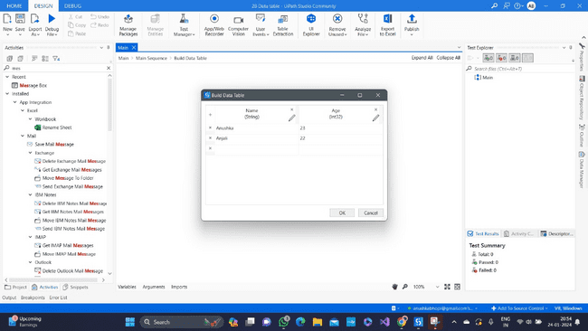

4. Add Output Data Table activity after Data Table activity adds Tabledata variable in the input of output data table and result variable in output part of the output data table.

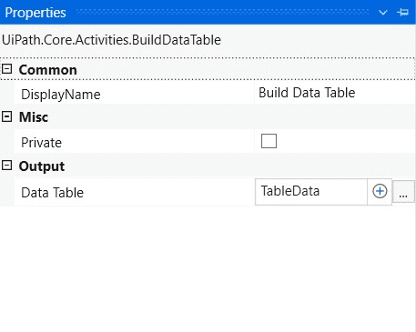 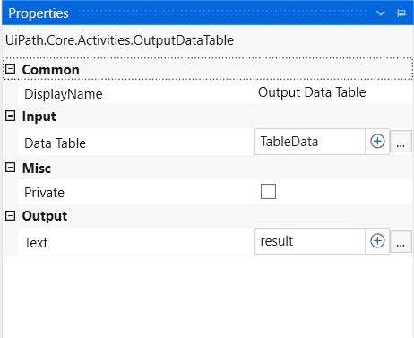

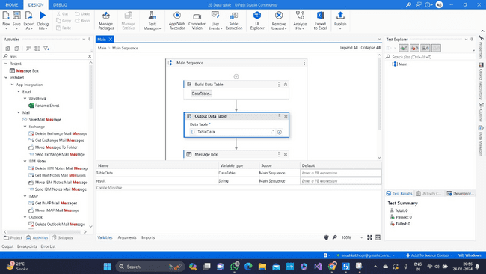

5. Add Message Box activity after the Output Data Table. In Text add a result variable to print data stored

in it.

6. Run the process using the Run button.

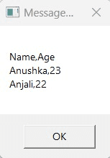

**6.DATETIME**

1. Add Sequence activity in designer panel.

2. Create variable name variable1 with Variable type System.DateTime, and Scope Sequence.

3. Add assign activity, inside sequence activity . Assign Now() to variable variable1 this will take system

current date and time and store into variable1.

4. Add Message Box activity after assign activity, add Text ‘variable1.ToLongDateString+ “, “+

variable1.ToLongTimeString’.

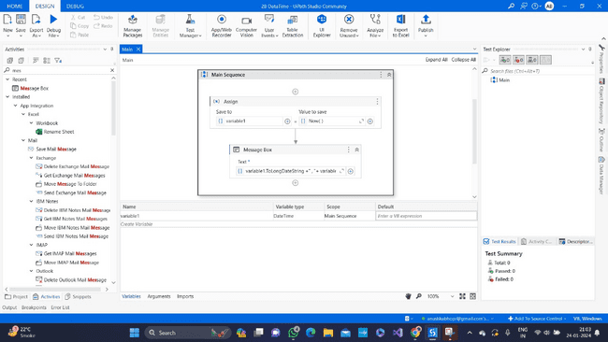

5. Run the process by clicking run button.

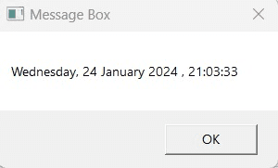

**Practical 3A**

**Create An Automation Uipath Project Using Decision Statements. (Take The Number From The User, The Check Is It Even Or Odd).**

**Process steps :**

1. Add Sequence activity inside the designer panel.

2. Inside the sequence add activity Input Dialog. Give the Dialog Title “The number is even or odd”, and

Input Label “Enter the number” both must be in double quotes. Select Input Type as “Text Box”, and the

value entered.

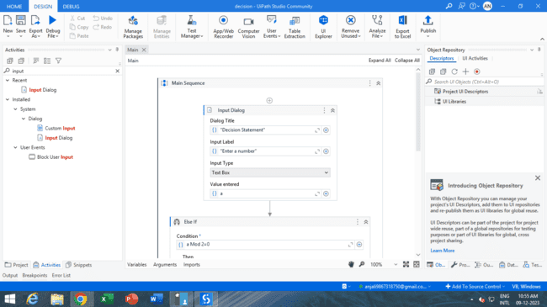

4. Add If activity (decision making) after the Input Dialog. Set Condition as “number Mod 2 =0” and inside

the Then block add Sequence along with Message Box activity, add Text along with the variable name

as “number.ToString+” is Even””.

5. Inside the Else block add Sequence along with Message Box activity, and add the text along with the

variable name as” number.ToString+ “ is Odd”.

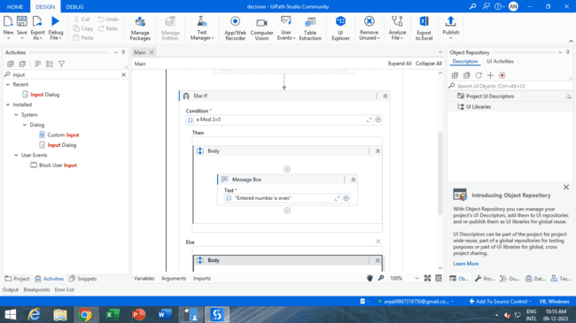

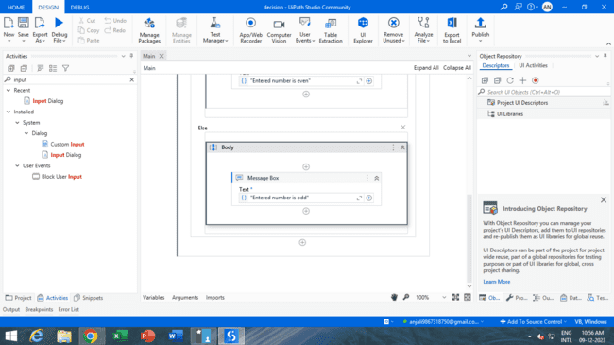

6. Run the process using Run Button

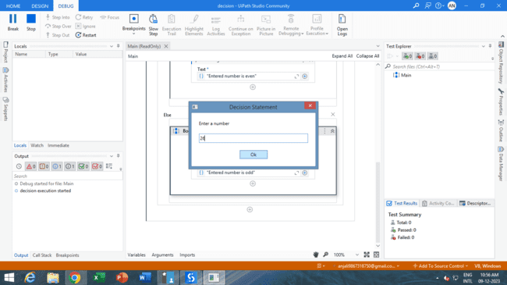 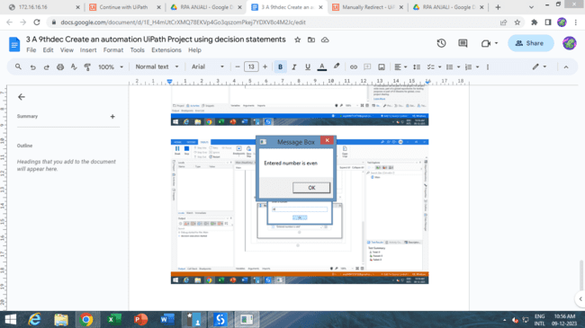

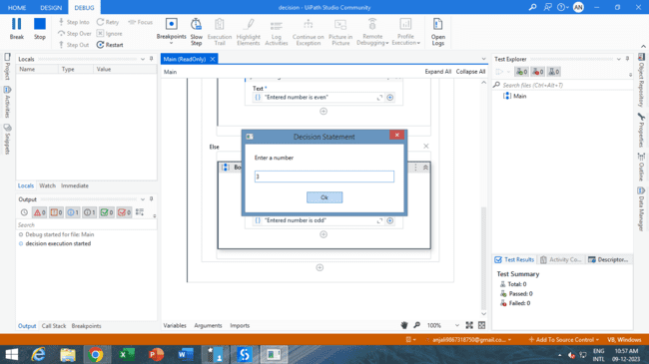 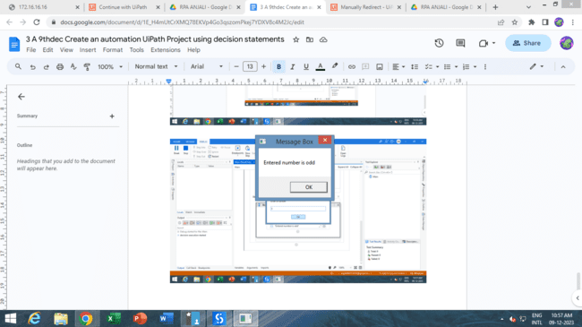

**PRACTICAL 3B**

**Create An Automation Uipath Project Using Looping Statements.**

**Process Steps :**

1. Add Sequence activity inside the designer panel.

2. Inside the Sequence add Do While activity.

3. Add Input Dialog activity in the Body of Do While, give the appropriate Dialog Title as “The number is

odd or even” and Input label as “Enter the number:” both must be in double quotes. Add Input Type as

Text Box and value entered.

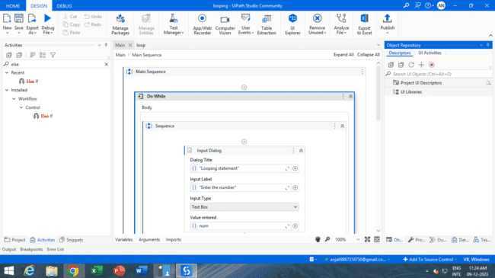

5. Add If activity after the Input Dialog set Condition as “ n Mod 2 = 0”. Inside Then block add Sequence

along with Message Box activity with Text as “ n.ToString+’ is even..’”.

6. Inside the Else block add Sequence along with Message Box. Add Text in Message Box as “ n.ToString+’

is odd’”.

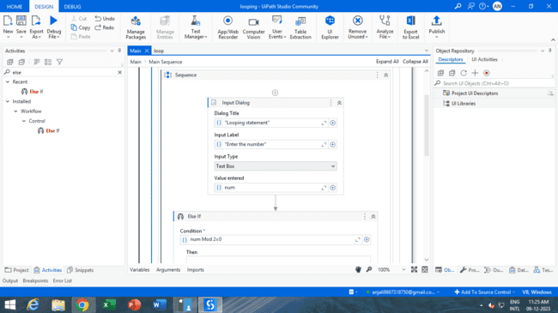

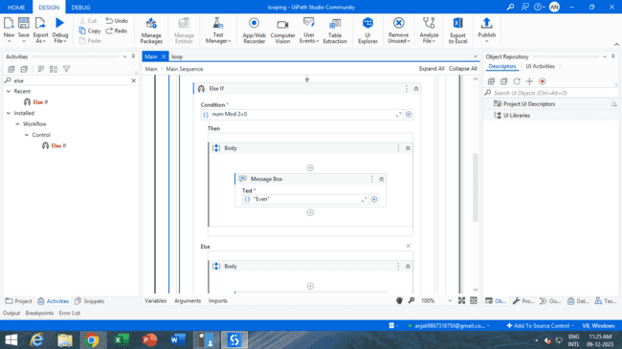

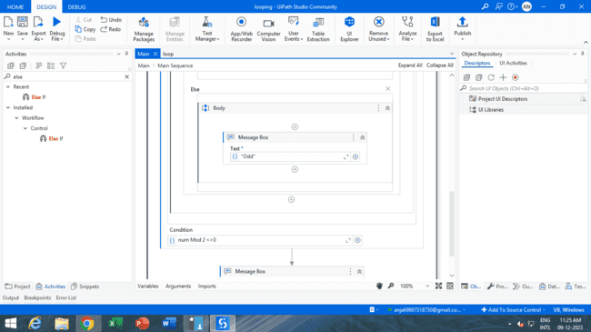

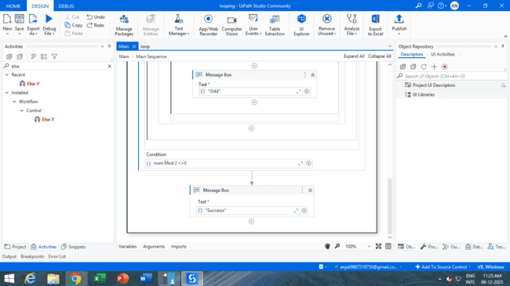

7. Add Condition inside Do While activity as “n Mod 2 <> 0”. The loop will continue the execution until

we get an even number.

8. Run the process using Run Button.

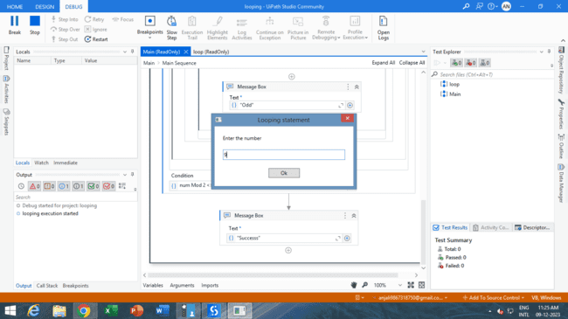 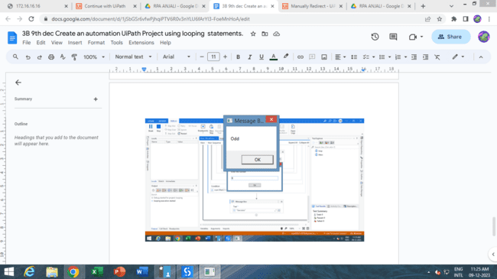

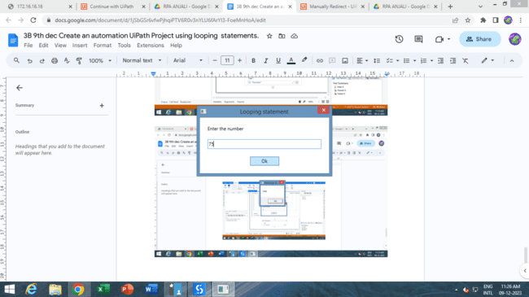 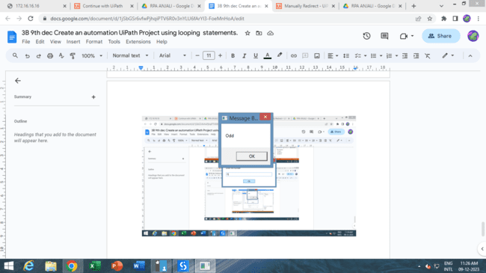

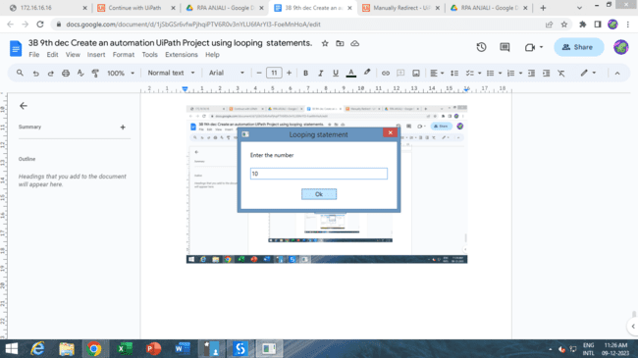 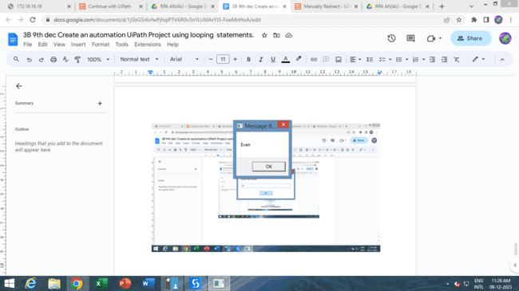

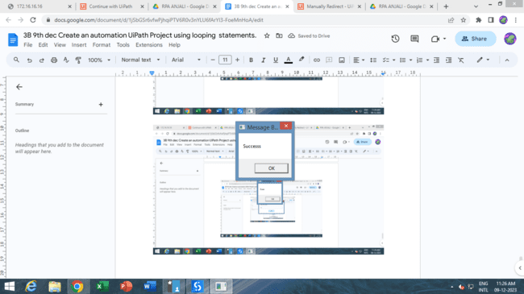

**Practical 4A**

**Automate any process using the basic recording. (Change the font, font style, and font size of written data inside the notepad).**

**Process steps :**

1. Add sequence activity inside the designer panel. Select basic recording from the ribbon and start

recording.

2. Open the notepad application by clicking on the Notepad Application icon on a desktop screen and click

on the confirmation button.

3. Select Type Into activity in the recording panel, indicate the notepad area where we type text, and

confirm it. Add the text “hello basic recording” and press the enter button.

4. Select Click activity from the recording panel, click on the Edit option in the notepad application and

click on the confirmation.

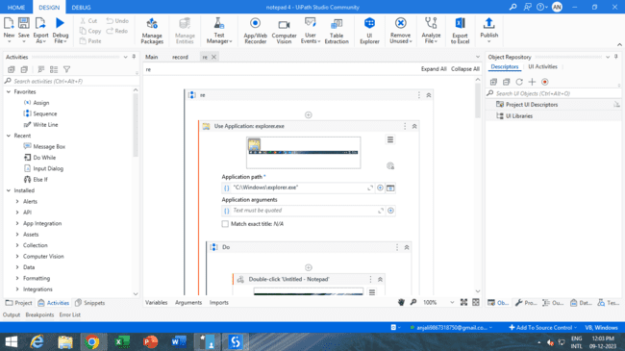

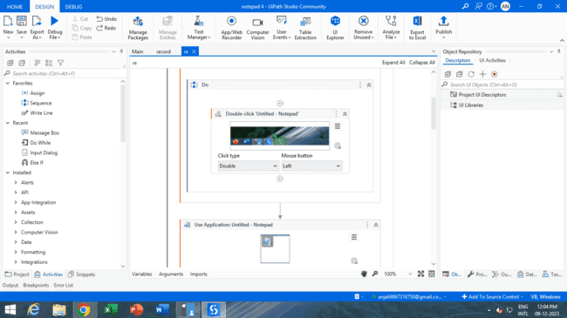

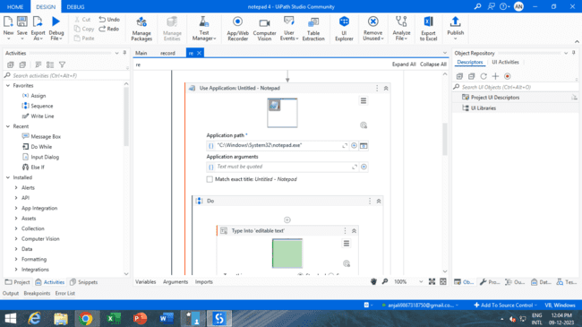

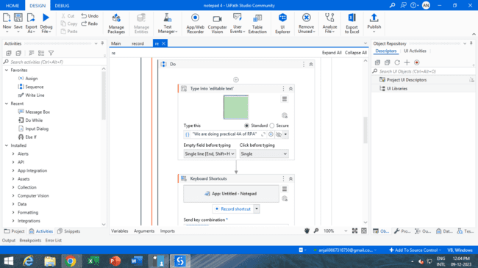

5. Select click activity from the recording panel, click on select all option inside the edit and confirm it.

Which selects all text on the screen.

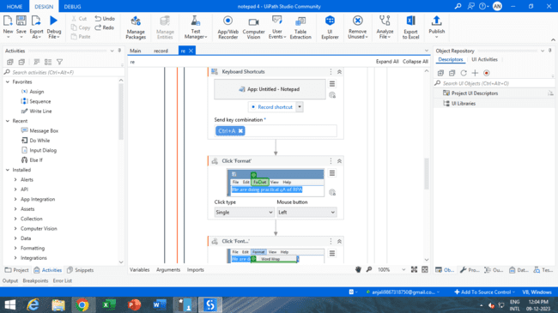

6. Add Click activity from the recording panel, click on the Format option in note pad application and click

on the confirmation button.

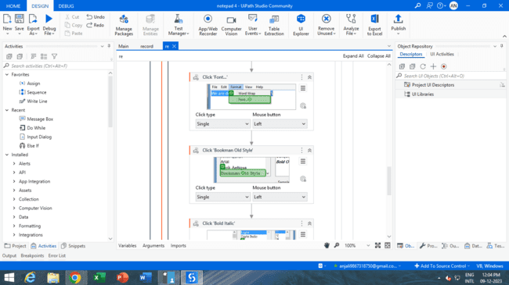

7. Select the Click activity from the recording panel, click on the Font option inside the Format and

confirm it. This will open a window that contains multiple font styles and sizes.

8. Add Click activity from the recording panel, select the font type from the list and confirm it.

9. Select Click activity from the recording panel, select the font style from the list and confirm it.

10. Select Click activity from the recording panel, select the font size and confirm it.

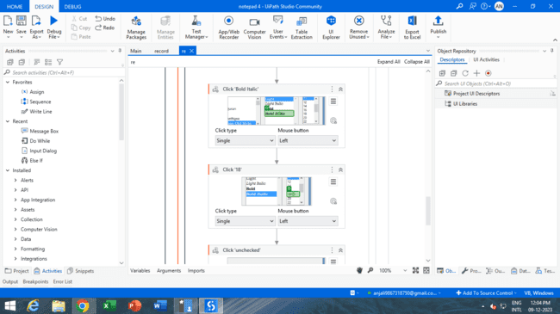

11. Select Click activity from the recording panel, and click on ok which changes the font style and size as

well.

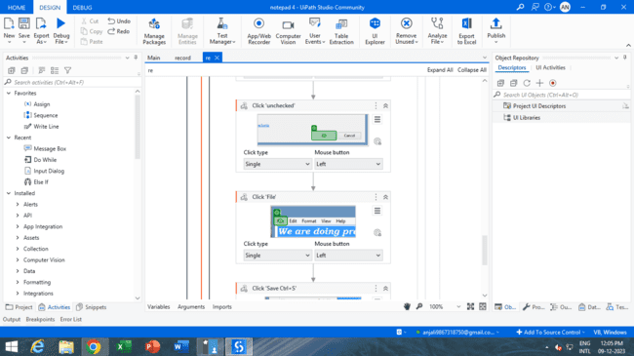

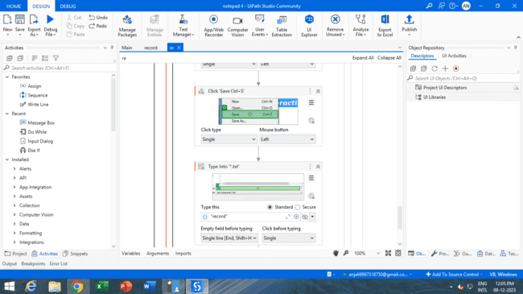

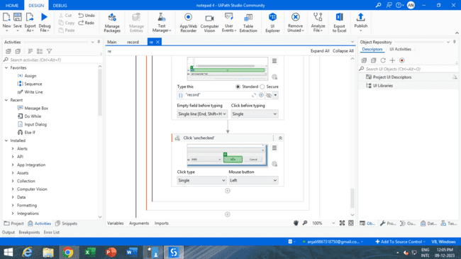

12. Run the process using Run Button, this will automate the process of changing the font style and size of

the entered text in the notepad application.

**PRACTICAL 4B**

**Automate Any Process Using Web Recording. (Jubin 8085 Simulator)**

**Process steps :**

1.Start recording

2.Select the url line in chrome

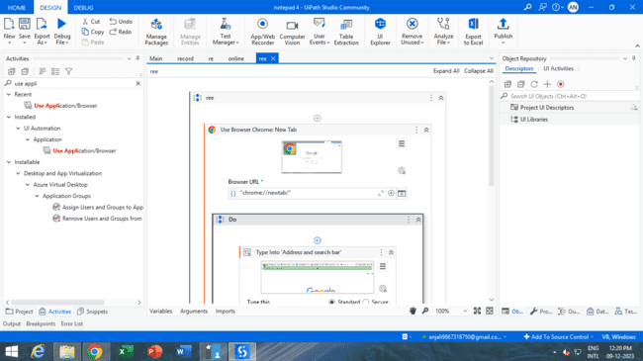

3.Search for Jubin 8085

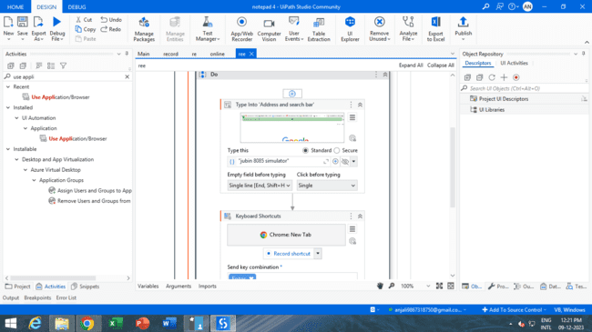

Select the Jubin download link

And download

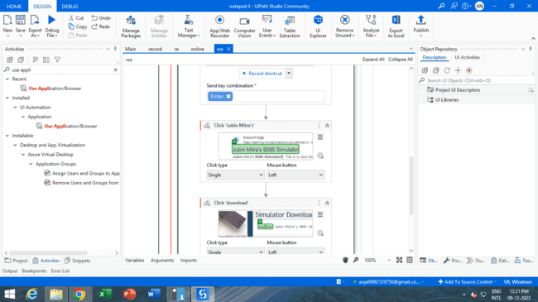

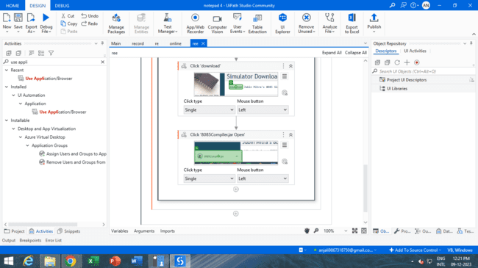

**PRACTICAL 5**

**Consider An Array Of Names. We Have To Find Out How Many Of Them Start With The Letter "A". Create An Automation Where The Number Of Names Starting With "A" Is Counted And The Result Is Displayed.**

**Process steps :**

1. Add sequence activity in the designer panel.

2. Create variables with name names and count respectively in the variable panel. The variable type for

names is Array of T[] along with String data type and count variable with Int32. And Scope as Sequence

for both variables.

3. Add For Each activity, assign For Each items in the Names variable. Within the body of For Each activity

add If activity, with the condition of ‘items.ToString.StartWith(“R”)’. If there is any name that starts with

the letter ‘R’(case sensitive) then it will go to Then block part of If activity.

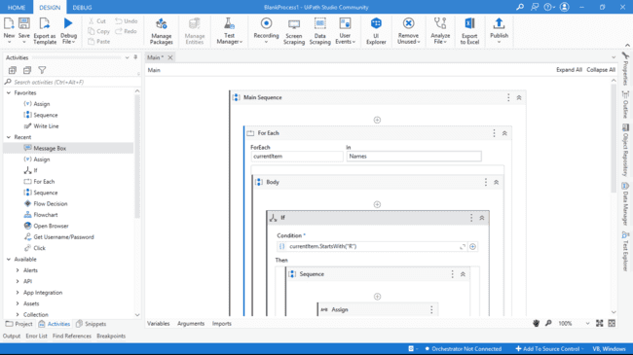

4. In Then block add Assign activity and assign the ‘count’ variable to ‘count+1 ‘. The count will be

incremented when there is more than one name starting with the letter ‘R’.

5. Outside the For Each activity add Message Box activity. Add Text as ‘count+” names available that start

with ‘R’. it will showcase items starting with the letter ’R’.

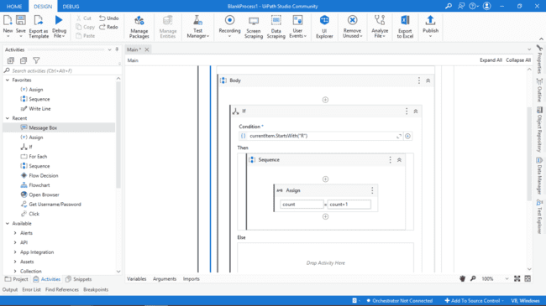

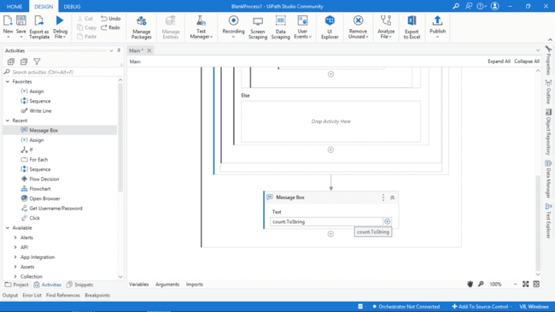

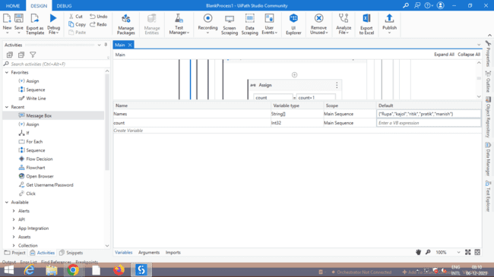

6. Run the process using the Run Button.

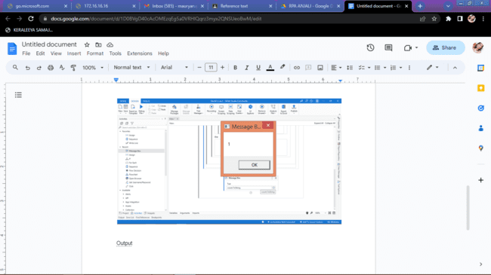

**PRACTICAL 6A**

**Create An Application Automating The Read, Write And Append Operation On An Excel File.**

**Process steps :**

1. Add Sequence activity inside the designer panel.

2. Inside the variable panel create variables results and Data_t with Variable Type String and Data

Table respectively, and both have scope as a sequence.

3. Inside the Sequence add Excel Process scope activity, which helps to perform excel operations.

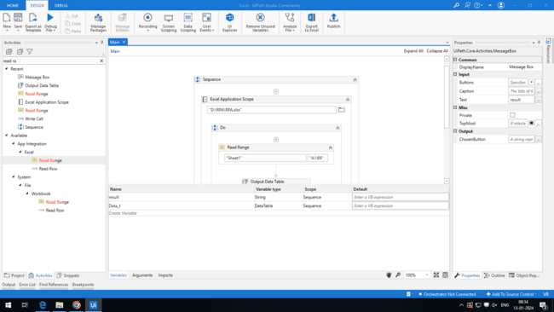

4. Add the Write Cell workbook activity, and add the appropriate workbook path.

Sheet name: “Pract6b”,

Cell write data: “H10”,

Text: “Hello”.

5. Add Read Cell Workbook activity, give the appropriate path,

Sheet name: “Pract6b”,

Cell number: “H10”.

Stored data into result variables.

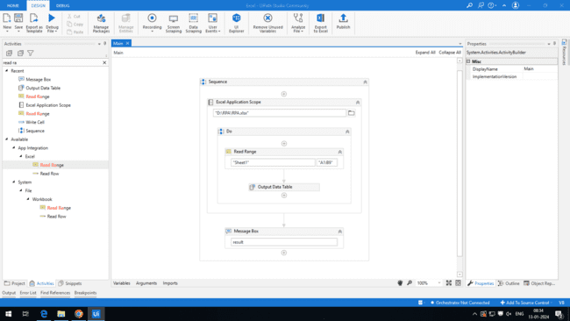

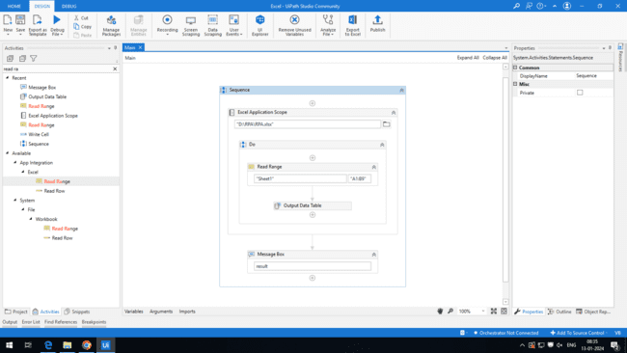

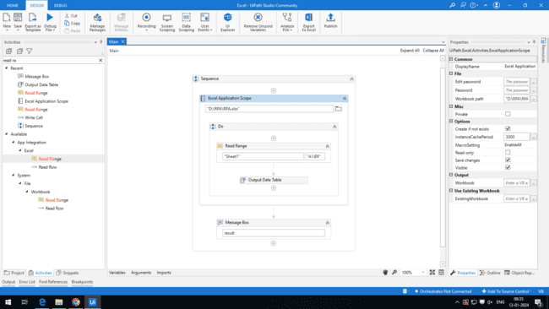

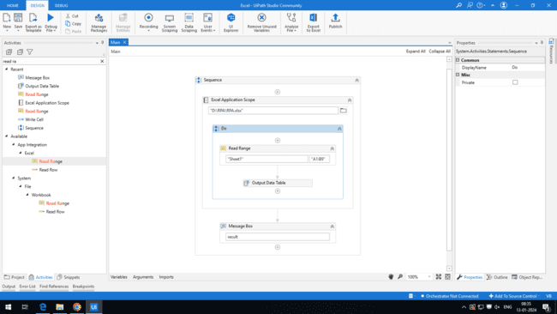



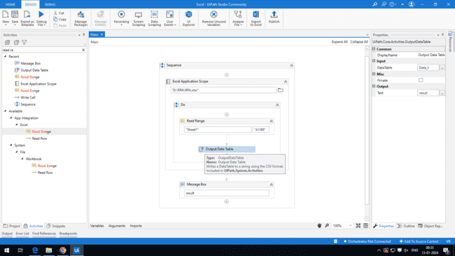

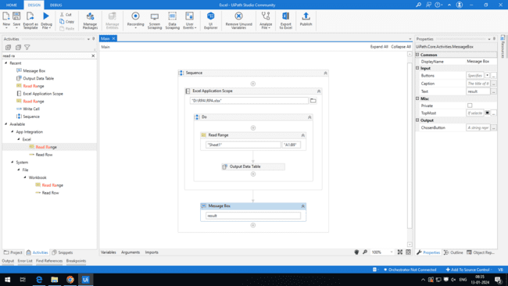

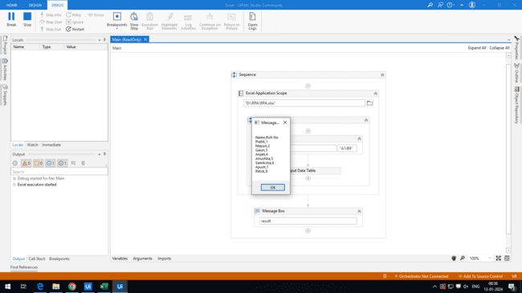

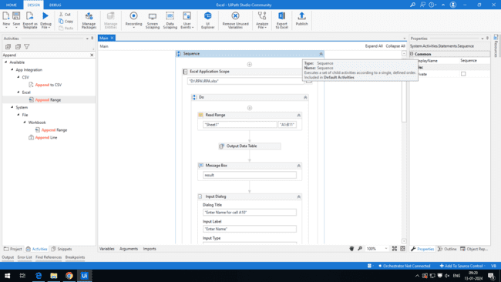

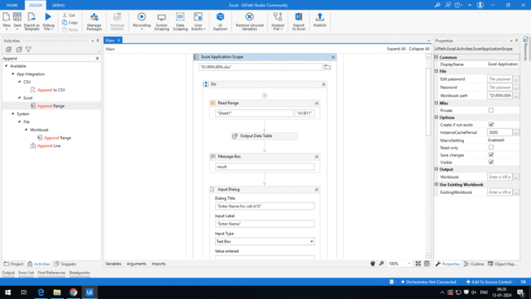



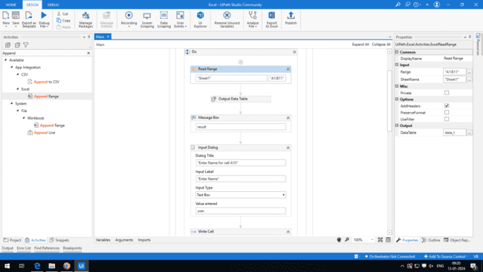

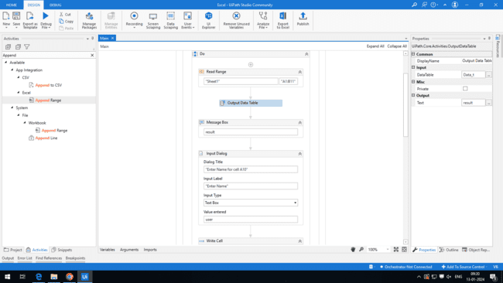

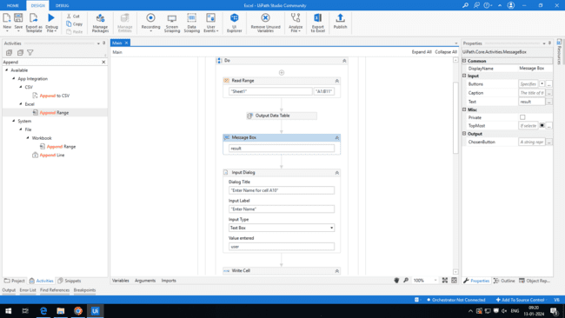

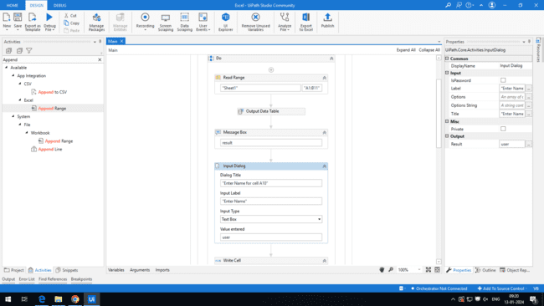

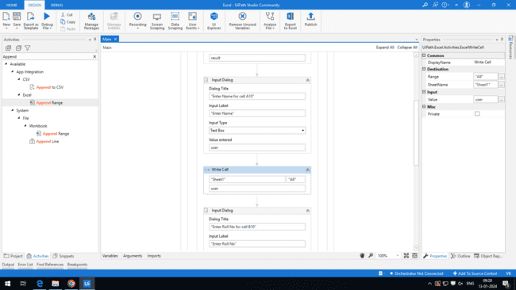

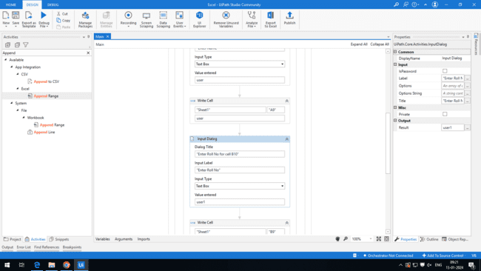

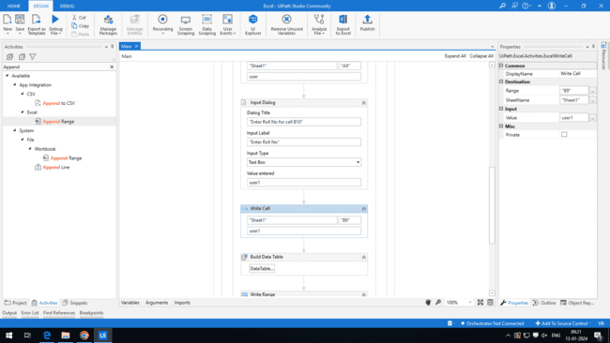

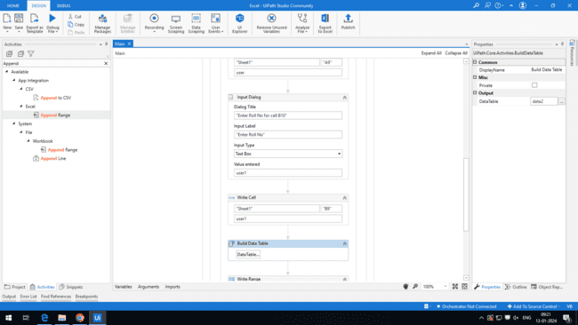

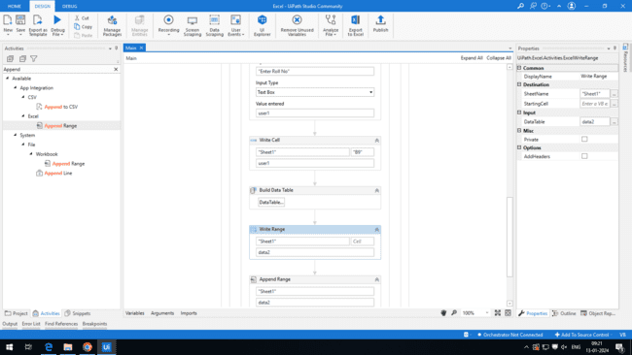

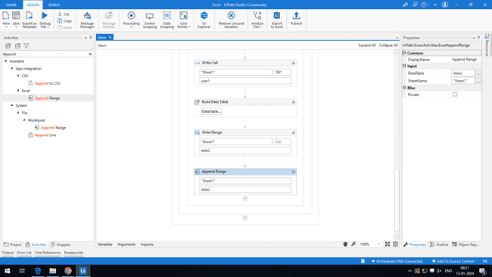

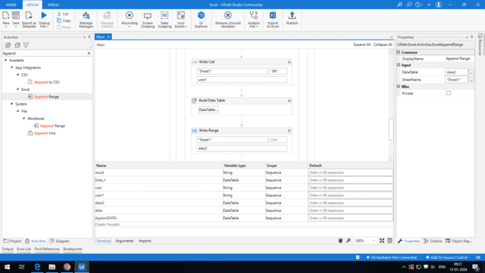

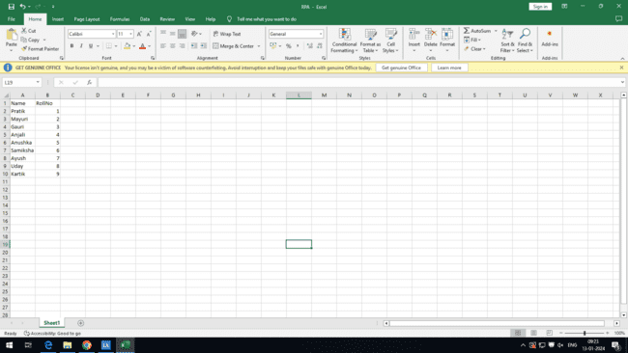

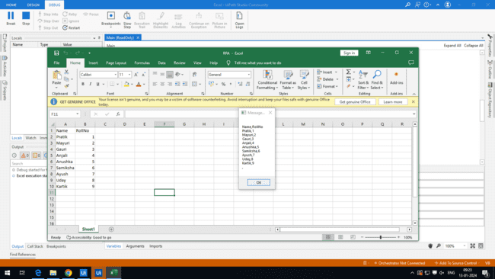 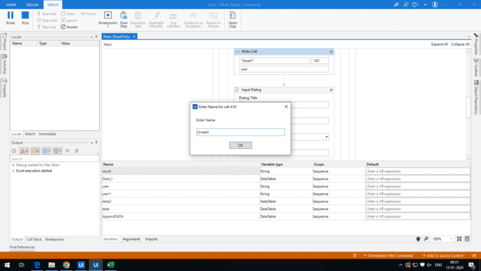 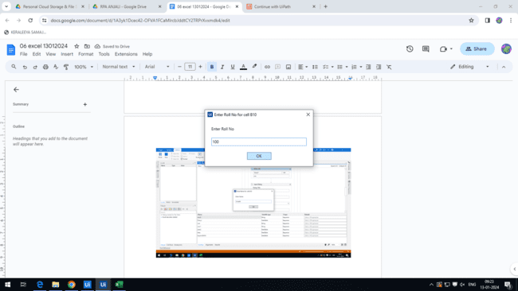

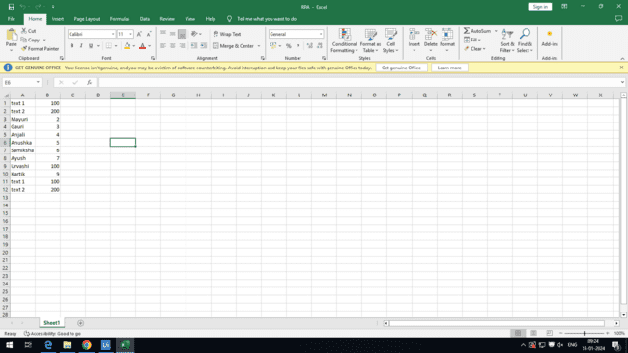

**PRACTICAL 7**

**Demonstrate The Following Activities In Uipath:**

**1. Mouse (Click, Double Click, And Hover)**

**2. Type Into**

**3. Type Secure Text**

**Process steps**

1. Add sequence activity in the designer

2.In Sequence , add the **Use Application** activity Indicate explorer in it

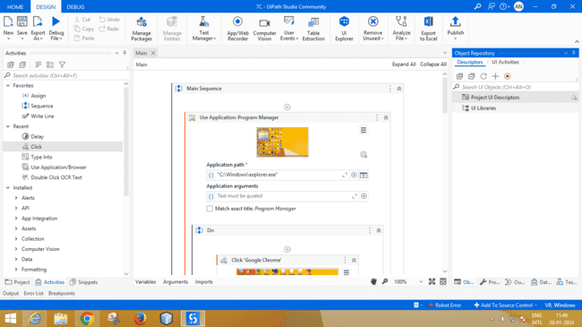

3.Inside Do add **Click activity** and **indicate Google Chrome**

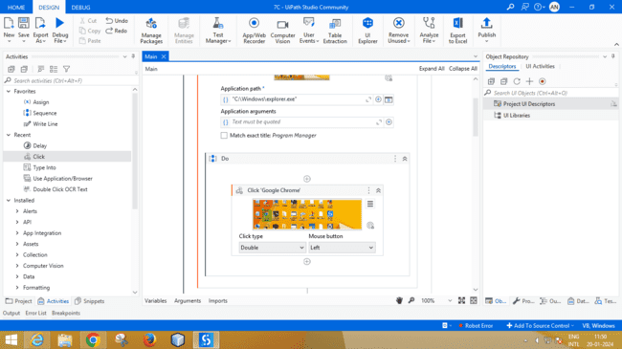

4.After that add the **Use Browser Chrome** ,indicate **Browser Url**

5.Inside Do add **Click activity** , Indicate **Gmail** on the browser

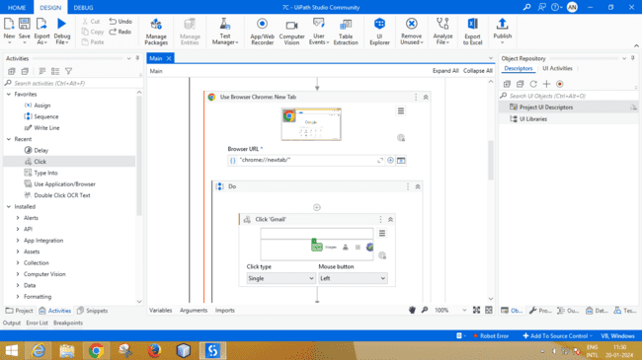

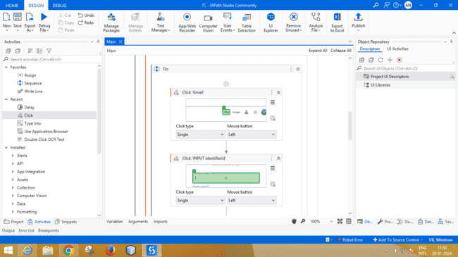

6.Add **click activity** and Indicate the **Input field** on the gmail

7.Add **Type into activity** ,after clicking the activity add **email address**

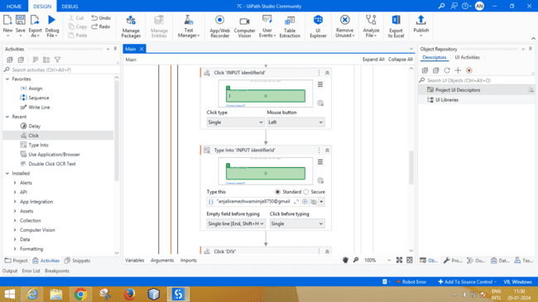

8.Add **click activity** and indicate on the **next** button

9.Then Add **delay activity** and provide delay of **00hh 00mm 05.000s**

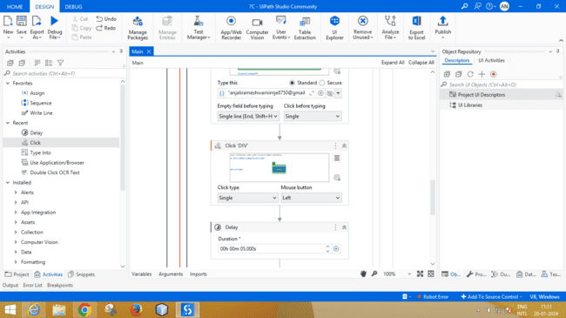

10.Add another Type into activity .Add text into into Type this (password)

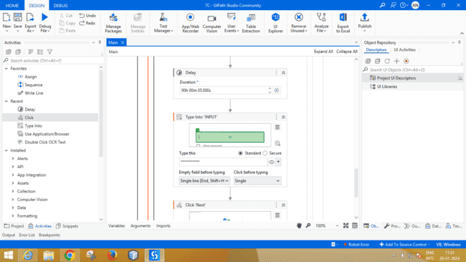

11.Then add click activity and Indicate next on the browser

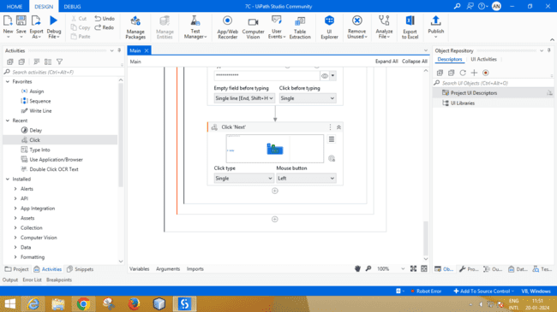

12. Run the process using Run Button

**PRACTICAL 8A**

**Demonstrate The Following Events In Uipath:**

**1. Image-Triggering Event**

**2. Element Triggering Event**

**3. System Triggering Event**

**Process steps :**

**1.Image trigger**

1.Add sequence inside the designer panel

2.Add process trigger scope inside the sequence

3.Add **Image trigger** inside the **Triggers** Indicate the image on the desktop **and**

Select the Mouse Button from the drop down list

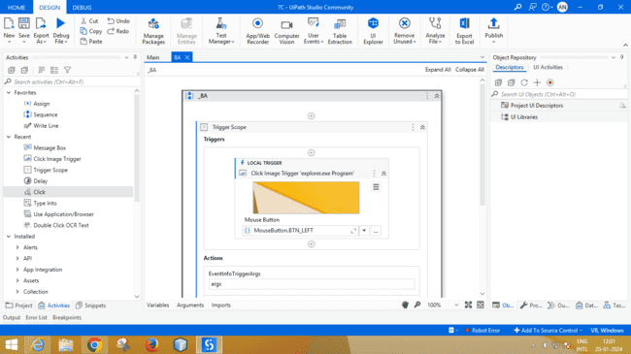

4.Add message box Activity inside the sequence of action part of trigger process scope ,add text “hello”

5. Press the run button

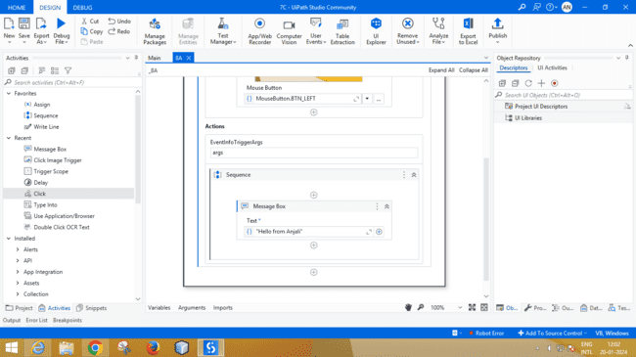

Process output

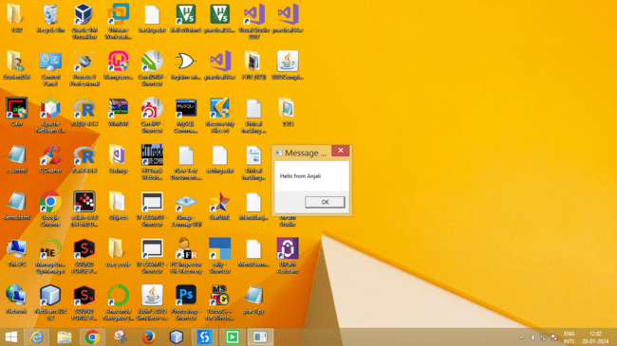

**2. Element triggering event**

1.Add Trigger scope activity inside the Sequence

2.Add Event trigger Activity inside the triggers ,Indicate the image (“ram lalla”) on desktop and select the left mouse button

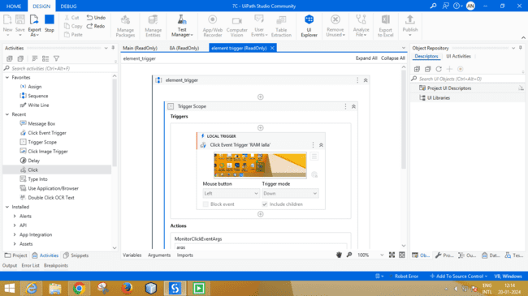

3.Add message box activity inside sequence of action part of triggers process scope ,add text “Jai shri Ram”

4.Run the process using **Run button**

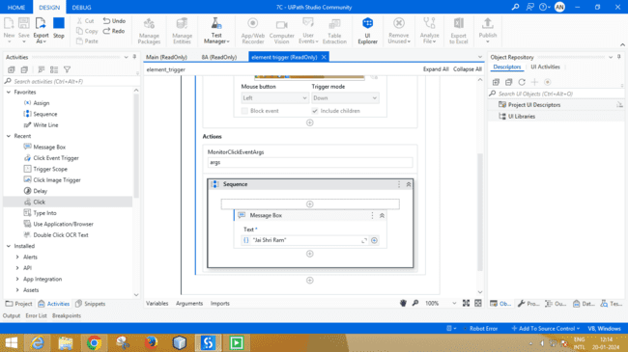

Output :

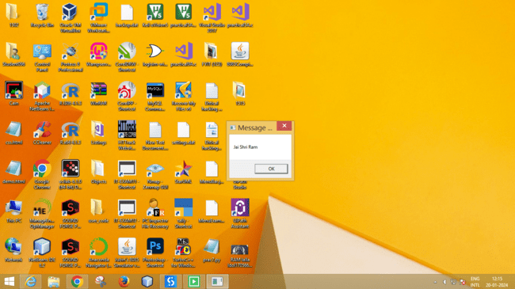

**3.System trigger**

**Process steps:**

1.Add Sequence activity inside the designer panel

2.Add Trigger scope activity inside the sequence

3.Add Hotkey trigger activity inside the trigger part and select the “enter” key

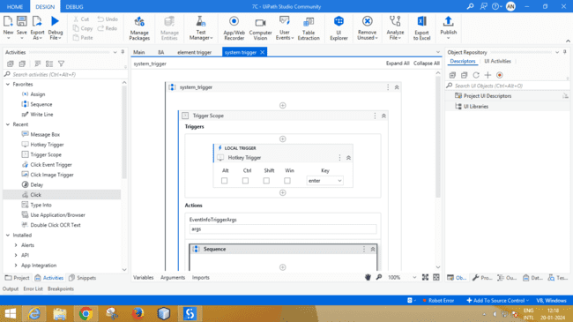

4.Action Sequence activity ,add Message Box activity add text as “Clicked enter key using system trigger”

5.Run the process using Run Button

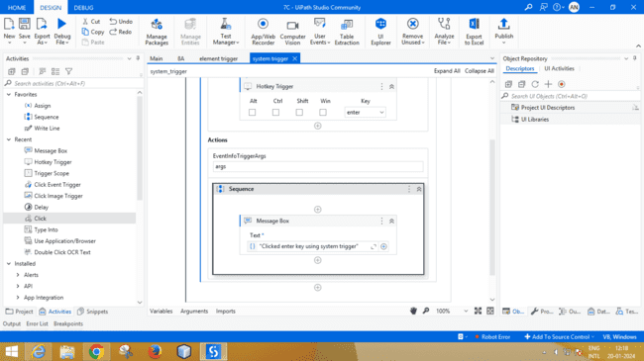

Process Output :

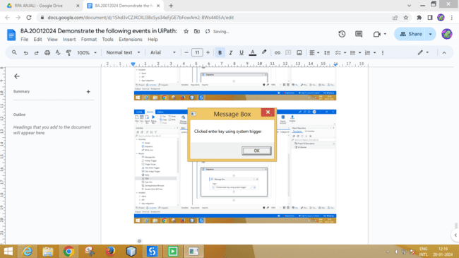

**Practical 9**

**Automate A Process For Sending Mail**

**Process steps :**

1.Drag and drop sequence activity in the designer panel

2.Add **Use Browser Chrome activity** inside sequence and indicate the URL

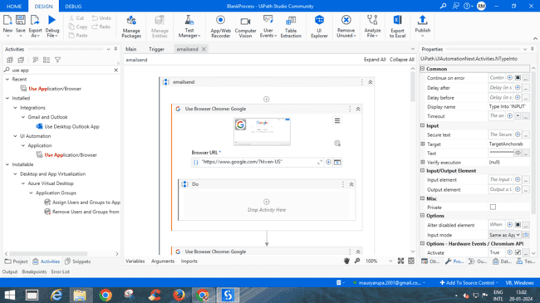

3.Add **click activity** inside the Do and **indicate Gmail** on the browser

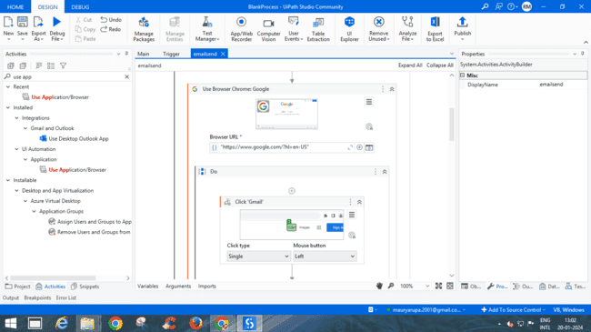

4. Add Click activity and Indicate the gmail address input field

5.After that add Type into activity and type the password

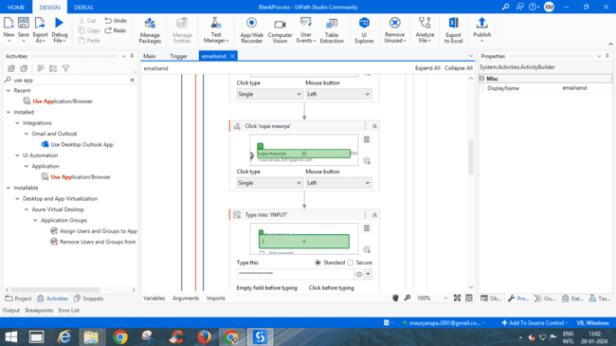

6.Add click Activity again and Indicate **Next** on browser

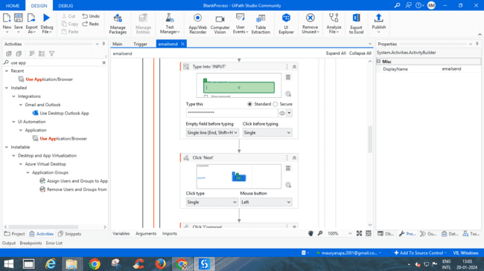

7.Add click activity and indicate on **compose** in the gmail window

8.Add **type into** and in Type this add the **sender mail** address

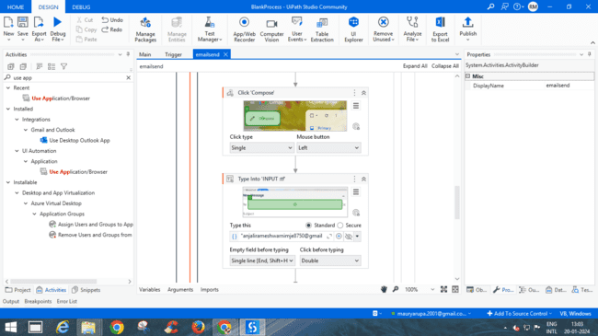

9. Add click Activity and Indicate the sender mail address

10.Add type into activity and in Type this (write any message)

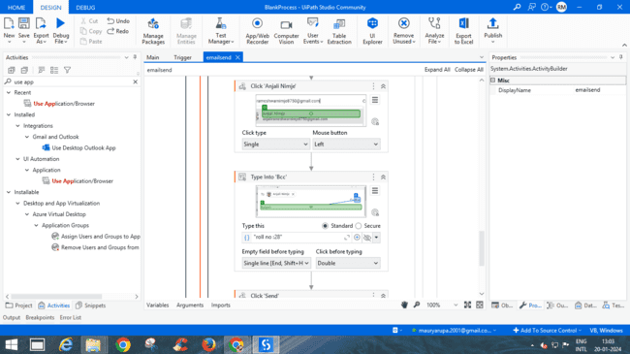

11.Then again **add click activity** and indicate **send**

